SIMATS ENGINEERING (SAVEETHA SCHOOL OF ENGINEERING)
Department of Computer Science and Engineering
CO3_AT1 — EXPERIMENT

Course Code: | DSA06 | Course Title: | Data Handling and Visualization
CO Assessed: | CO3 – Construction (BL3) | Assessment: | Assessment Tool 1 – Experiment
Weightage: | 20% of CIA | Total Marks: | 25 (5 Questions × 5 Marks)
CO3 Statement: | Apply appropriate experimental charting techniques — pie charts, bean plots, violin plots, box plots, and stacked bar charts — to construct accurate visualizations from given data.(BL3)
Student Name: | P. SIDDARDHA | Reg. No.: | 192424271
Section / Batch: | AIDS/2024 | Date: | 12-08-2026

Code of Conduct
I ____P. SIDDARDHA (192424271)_____ (Name / Reg No) certify that this submission is my original work and that I have adhered to the guidelines specified for this assessment. I understand that any violation of academic integrity rules will result in disciplinary action.

Signature of the Student: ____P. SIDDARDHA____

Instructions
- This test contains 5 questions, each carrying 5 marks. Total: 25 Marks.
- No negative marking. Unanswered questions carry zero marks.
- No calculators or electronic devices permitted.
- Duration: 75 minutes.
- Graph paper or a ruler is recommended for accurate, to-scale drawing.
- Show all calculations (e.g., pie chart angles, five-number summary, IQR) as part of your answer.
- Every chart must include a title, correctly labeled axes (where applicable), and a legend where relevant.

Annexure A – EXPERIMENT

CO3-AT1

Problem 3 — Pie Chart

Given Data
Candidate | Votes
A | 50
B | 30
C | 15
D | 5
Total | 100
Chart Type
Pie Chart
A pie chart is appropriate because the data represent the proportion of a fixed total of 100 votes received by four candidates. Each slice represents the candidate's share of the total votes.
Angle Calculation
The formula used is:
Angle = (Votes / Total Votes) × 360°
For Candidate A:
(50 / 100) × 360° = 180°
For Candidate B:
(30 / 100) × 360° = 108°
For Candidate C:
(15 / 100) × 360° = 54°
For Candidate D:
(5 / 100) × 360° = 18°
Calculation Table
Candidate | Votes | Percentage | Angle
A | 50 | 50% | 180°
B | 30 | 30% | 108°
C | 15 | 15% | 54°
D | 5 | 5% | 18°
Total | 100 | 100% | 360°
Construction Steps
- Enter the candidate and vote data.
- Calculate the percentage and angle for each candidate.
- Draw a circle representing 360°.
- Divide the circle into slices of 180°, 108°, 54°, and 18°.
- Label every slice with the candidate name and vote count.
- Use different colors for the four candidates.
- Add the title Class Election Votes.
- Add a legend identifying each candidate.
Interpretation
Candidate A received the largest share with 50% of the votes, represented by a 180° slice. Candidate D received the smallest share with only 5%, represented by an 18° slice. The complete pie represents all 100 votes.
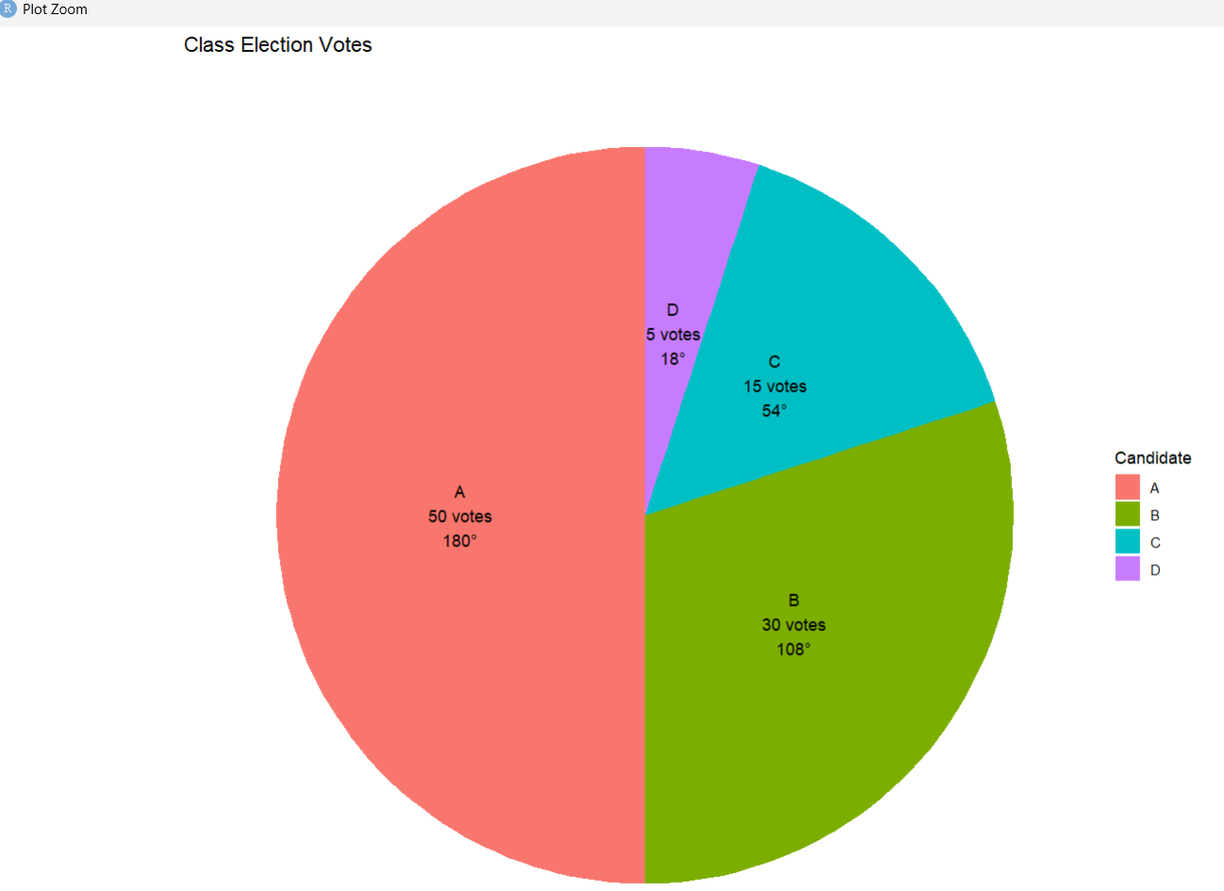
Problem 8 — Bean Plot

Given Data
Day | Temperature (°C)
Day 1 | 22
Day 2 | 24
Day 3 | 23
Day 4 | 27
Day 5 | 29
Day 6 | 26
Day 7 | 25
Day 8 | 24
Day 9 | 23
Day 10 | 28
Chart Type
Bean Plot
A bean plot is appropriate because the question asks for the distribution of a numerical variable. It combines a density-shaped distribution with the individual observations, making both the overall distribution and individual temperature values visible.
Ordered Data
22, 23, 23, 24, 24, 25, 26, 27, 28, 29
Construction Steps
- Enter the ten temperature observations.
- Use Temperature (°C) as the numerical variable.
- Construct a bean-shaped density representing the distribution.
- Display the individual observations within the bean.
- Mark the mean/reference line.
- Label the numerical axis as Temperature (°C).
- Give the chart the title Daily Temperature Distribution – Bean Plot.
- Ensure that the individual observations and density shape are clearly visible.
R Implementation
library(beanplot)

temperature <- c(
22, 24, 23, 27, 29,
26, 25, 24, 23, 28
)

beanplot(
temperature,
names = "Daily Temperature",
method = "jitter",
side = "no",
what = c(TRUE, TRUE, TRUE, TRUE),
col = "lightblue",
border = "black",
innerborder = "black",
maxwidth = 0.9,
maxstripline = 0.9,
jitter = 0.08,
beanlines = "mean",
overallline = "mean",
xlab = "Daily Temperature",
ylab = "Temperature (°C)",
main = "Daily Temperature Distribution - Bean Plot"
)
Interpretation
The bean plot shows that the temperatures are mainly concentrated between 23°C and 25°C. The observations extend from 22°C to 29°C. The distribution gradually narrows toward the lower and higher temperatures. There is no extreme outlier in the dataset.
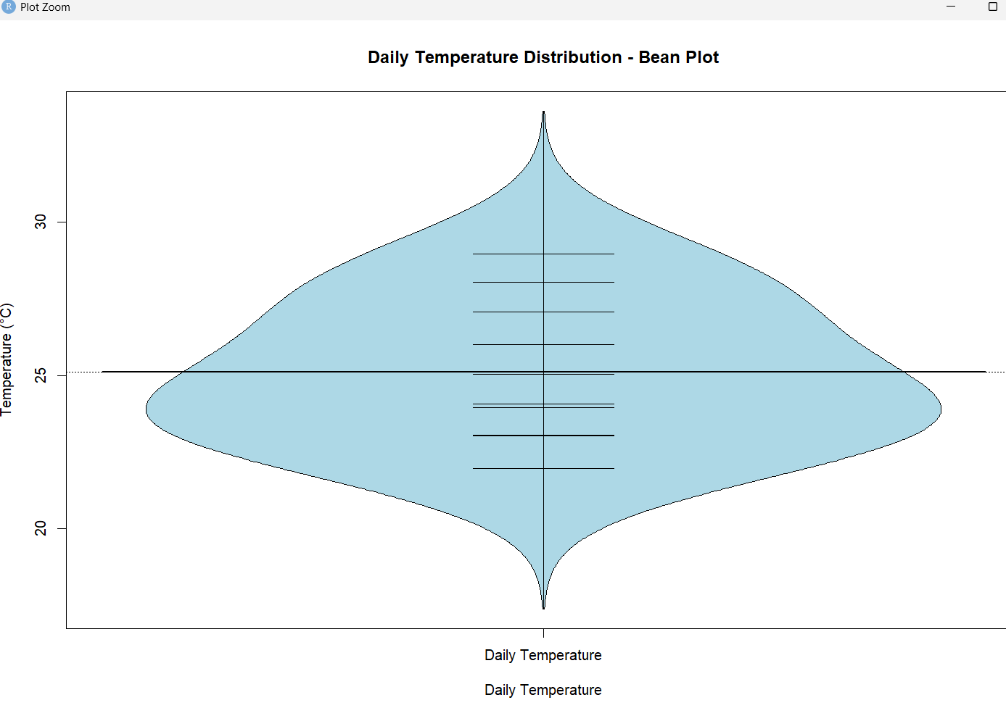

Problem 13 — Violin Plot

Given Data
Order | Delivery Time (minutes)
1 | 15
2 | 18
3 | 20
4 | 22
5 | 25
6 | 25
7 | 28
8 | 30
9 | 35
10 | 60
Chart Type
Violin Plot
A violin plot is appropriate because it shows the distribution and density of delivery times. The width of the violin indicates where observations are concentrated, while the long tail makes unusually high delivery times visible.
Construction Steps
- Enter the ten delivery-time observations.
- Use Delivery Time as the numerical variable.
- Place delivery time on the vertical axis.
- Construct a violin-shaped density around the central axis.
- Display individual observations using jittered points if required.
- Label the vertical axis as Delivery Time (minutes).
- Add the title Delivery Time Distribution – Violin Plot.
- Ensure the upper tail is clearly visible.
R Implementation
library(ggplot2)

data_q13 <- data.frame(
Order = 1:10,
Delivery_Time = c(
15, 18, 20, 22, 25,
25, 28, 30, 35, 60
)
)

ggplot(
data_q13,
aes(x = "Delivery Time", y = Delivery_Time)
) +
geom_violin(
fill = "lightblue",
color = "black",
trim = FALSE
) +
geom_jitter(
width = 0.08,
size = 3
) +
labs(
title = "Delivery Time Distribution - Violin Plot",
x = "",
y = "Delivery Time (minutes)"
) +
theme_minimal()
Interpretation
Most delivery times are concentrated between approximately 20 and 35 minutes, with the repeated value of 25 minutes indicating a strong concentration around that region. The value 60 minutes creates a long upper tail and represents an unusually long delivery compared with the remaining observations.

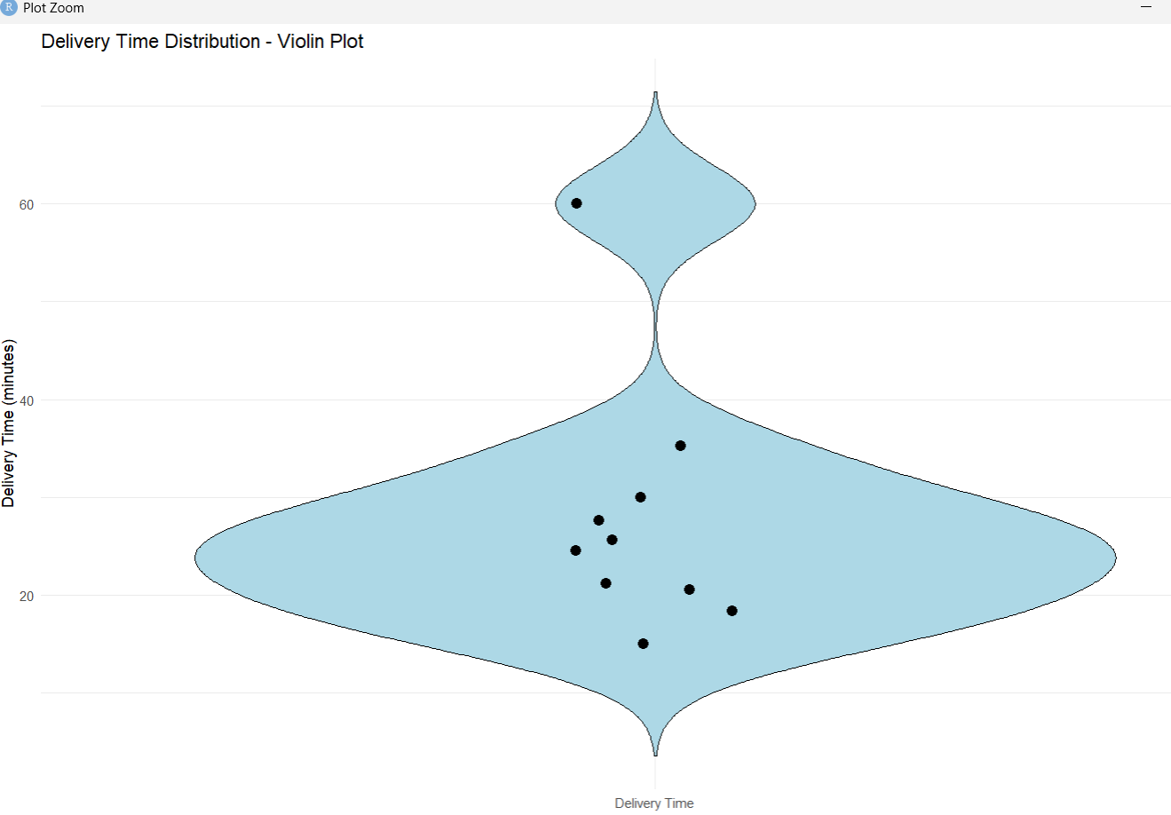

Problem 18 — Box Plots

Given Data
Section | Scores
Section A | 60, 65, 68, 70, 72, 75, 80
Section B | 40, 50, 55, 60, 65, 70, 95
Chart Type
Comparative Box Plot
A box plot is appropriate because it provides a direct comparison of the median, quartiles, spread, and possible extreme values between the two sections.
Section A — Five-Number Summary
Ordered data:
60, 65, 68, 70, 72, 75, 80
- Minimum = 60
- Q1 = 65
- Median = 70
- Q3 = 75
- Maximum = 80
Therefore:
Five-number summary = (60, 65, 70, 75, 80)
IQR:
IQR = Q3 − Q1
IQR = 75 − 65 = 10
Section B — Five-Number Summary
Ordered data:
40, 50, 55, 60, 65, 70, 95
- Minimum = 40
- Q1 = 50
- Median = 60
- Q3 = 70
- Maximum = 95
Therefore:
Five-number summary = (40, 50, 60, 70, 95)
IQR:
IQR = 70 − 50 = 20
Comparison Table
Measure | Section A | Section B
Minimum | 60 | 40
Q1 | 65 | 50
Median | 70 | 60
Q3 | 75 | 70
Maximum | 80 | 95
IQR | 10 | 20
Construction Steps
- Enter the scores for Section A and Section B.
- Create a categorical variable named Section.
- Create a numerical variable named Score.
- Place Section on the horizontal axis.
- Place Score on the vertical axis.
- Select Box Plot.
- Create one box for Section A and one box for Section B.
- Label the vertical axis as Test Score.
- Add the title Comparison of Test Scores – Section A vs Section B.
- Display individual observations if required.
R Implementation
library(ggplot2)

data_q18 <- data.frame(
Section = c(
rep("Section A", 7),
rep("Section B", 7)
),
Score = c(
60, 65, 68, 70, 72, 75, 80,
40, 50, 55, 60, 65, 70, 95
)
)

ggplot(
data_q18,
aes(x = Section, y = Score, fill = Section)
) +
geom_boxplot() +
geom_jitter(
width = 0.08,
size = 2
) +
labs(
title = "Comparison of Test Scores",
x = "Section",
y = "Test Score"
) +
theme_minimal()
Interpretation
Section A has a higher median of 70 compared with Section B's median of 60. Section A has an IQR of 10, while Section B has an IQR of 20, showing that Section B has greater variability. Section B also contains the high score of 95, which extends considerably beyond the rest of the observations.
Therefore, Section A has higher and more consistent scores, while Section B has lower and more widely dispersed scores.
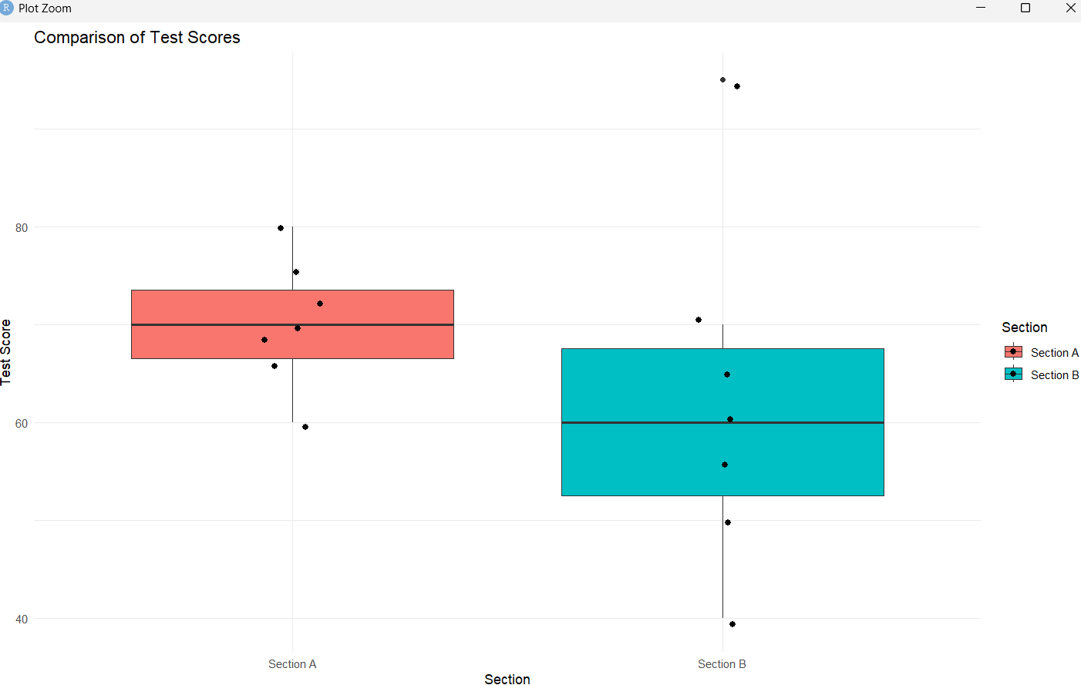

Problem 23 — Stacked Bar Chart

Given Data
Year | Department | Headcount
2022 | Engineering | 40
2022 | Sales | 25
2022 | Support | 15
2023 | Engineering | 55
2023 | Sales | 30
2023 | Support | 20
Chart Type
Stacked Bar Chart
A stacked bar chart is appropriate because it simultaneously shows the total headcount for each year and the departmental composition of that total.
Total Headcount Calculations
For 2022:
40 + 25 + 15 = 80 employees
For 2023:
55 + 30 + 20 = 105 employees
Departmental Percentage Composition
2022
Engineering:
40 / 80 × 100 = 50%
Sales:
25 / 80 × 100 = 31.25%
Support:
15 / 80 × 100 = 18.75%
2023
Engineering:
55 / 105 × 100 = 52.38%
Sales:
30 / 105 × 100 = 28.57%
Support:
20 / 105 × 100 = 19.05%
Summary Table
Year | Engineering | Sales | Support | Total
2022 | 40 | 25 | 15 | 80
2023 | 55 | 30 | 20 | 105
Construction Steps
- Enter Year, Department, and Headcount.
- Place Year on the horizontal axis.
- Place Headcount on the vertical axis.
- Select Bar as the mark type.
- Place Department on Color.
- Keep stacking enabled so departments form segments within each year's bar.
- Display the headcount values on the individual segments.
- Add a legend identifying Engineering, Sales, and Support.
- Label the vertical axis as Headcount.
- Add the title Company Headcount by Department and Year.
R Implementation
library(ggplot2)

data_q23 <- data.frame(
Year = c(
2022, 2022, 2022,
2023, 2023, 2023
),
Department = c(
"Engineering",
"Sales",
"Support",
"Engineering",
"Sales",
"Support"
),
Headcount = c(
40, 25, 15,
55, 30, 20
)
)

ggplot(
data_q23,
aes(
x = factor(Year),
y = Headcount,
fill = Department
)
) +
geom_bar(stat = "identity") +
geom_text(
aes(label = Headcount),
position = position_stack(vjust = 0.5),
color = "white"
) +
labs(
title = "Company Headcount by Department and Year",
x = "Year",
y = "Headcount",
fill = "Department"
) +
theme_minimal()

Interpretation
The total company headcount increased from 80 employees in 2022 to 105 employees in 2023, an increase of 25 employees or 31.25%.
Engineering remained the largest department, increasing from 40 to 55 employees. Sales increased from 25 to 30, while Support increased from 15 to 20.
The stacked bar chart clearly shows both the growth in total workforce and the departmental composition for each year.
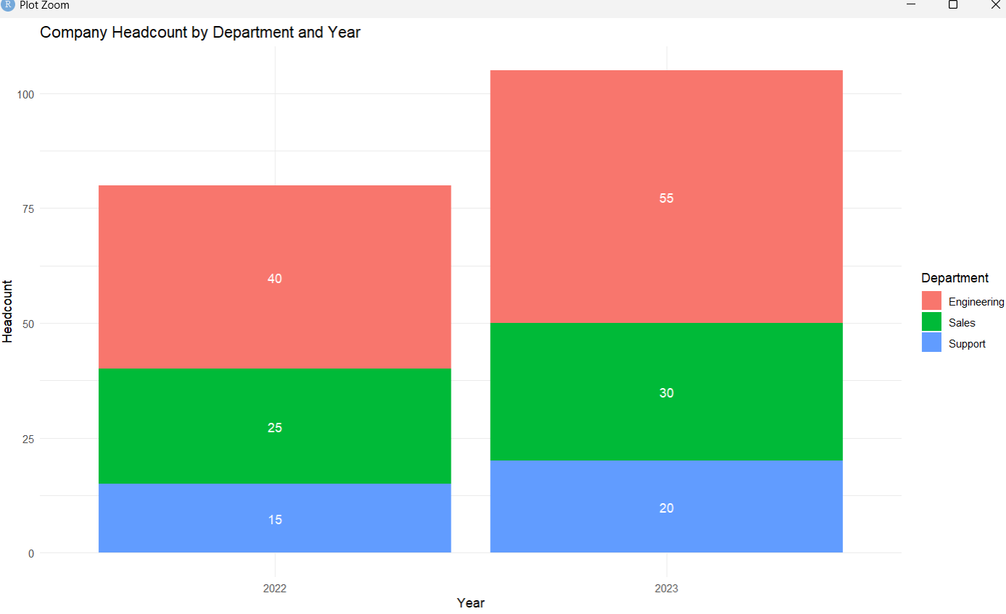
Overall Conclusion
The five visualizations were selected according to the characteristics of each dataset. The pie chart represents parts of a fixed total, the bean plot represents the distribution and individual observations of temperature data, the violin plot displays the density and concentration of delivery times, the box plot compares median and spread between two sections, and the stacked bar chart displays both total headcount and departmental composition.
All charts include appropriate titles, labels, legends where required, and calculations or construction details. The visualizations accurately represent the given data and allow the important patterns, comparisons, proportions, distributions, and totals to be identified clearly.

Rubrics for Calculation ASSESSMENT RUBRIC
AT1 — Experiment
CO3 · BT3: Apply ·
This rubric is used to assess student responses to the CO3-AT1 Experiment, in which students are given a small dataset and must construct an accurate pie chart, bean plot, violin plot, box plot, or stacked bar chart.

Criteria | Weightage | Level 4 – Exemplary | Level 3 – Proficient | Level 2 – Developing | Level 1 – Beginning
Understanding of Concepts | 25% | Demonstrates thorough, accurate understanding of the correct chart type (pie, bean, violin, box, or stacked bar) and the elements required to construct it for the given data. | Good understanding of the required chart type and construction elements, with only minor gaps. | Basic understanding of chart construction, but with some misconceptions about the correct chart type or required elements. | Poor understanding of core construction concepts; selects a chart type fundamentally unsuited to the data.
Explanation | 25% | Shows detailed, clearly worked calculations (e.g., pie chart angles, five-number summary, IQR, stacked totals) and explains each construction step. | Shows clear calculations and construction steps, with adequate explanation for most parts. | Calculations or construction steps are shown but incomplete, or explanations are superficial. | Little or no working shown; calculations and construction steps are missing or unexplained.
Application | 20% | Effectively applies chart construction techniques to produce a complete, accurate chart correctly matched to the data. | Applies construction techniques to produce a correct chart, with only minor errors. | Limited application of construction techniques; the chart partially represents the data but has notable errors. | Fails to apply appropriate construction techniques; the chart does not correctly represent the data.
Organization | 15% | The chart is neatly and logically constructed, with a title, correctly labeled axes or slices, a legend where applicable, and elements in a clear order. | The chart is well organized, with only minor issues in labeling, legend, or layout. | Basic construction; required elements (title, labels, legend) are present but poorly arranged or partly missing. | Poorly constructed; the chart is missing key elements such as a title, labels, or a legend.
Accuracy | 10% | The chart is completely accurate — all values, proportions, quartiles, and calculations correctly match the given data. | Mostly accurate, with only minor omissions or a small error in one value or calculation. | Partially correct; some plotted values, proportions, or calculations are missing or incorrect. | Largely inaccurate; major errors in plotted values, proportions, or calculations relative to the given data.

Scoring Guide
For each criterion, award a performance level (1–4) based on the descriptors above. Multiply the level achieved (as a percentage of 4, i.e., Level 4 = 100%, Level 3 = 75%, Level 2 = 50%, Level 1 = 25%) by the criterion's weightage, then sum across all five criteria to obtain the total score out of 100%.

Faculty In-charge | Course Coordinator | Head of Department
Signature: _______________ | Signature: _______________ | Signature: _______________
Date: ___________________ | Date: ___________________ | Date: ___________________

